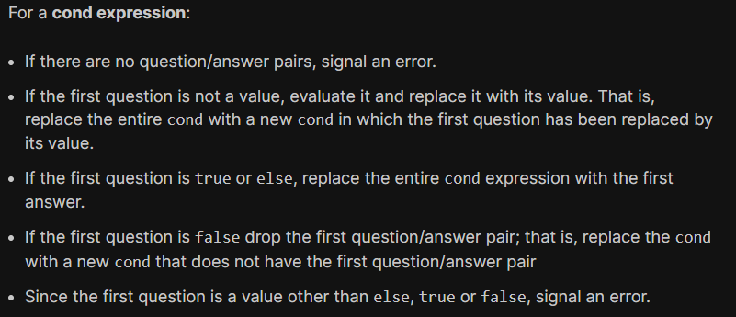

<https://courses.edx.org/courses/course-v1:UBCx+HtC1x+2T2017/a24b7341216346f2a5c99c6391f64229/>

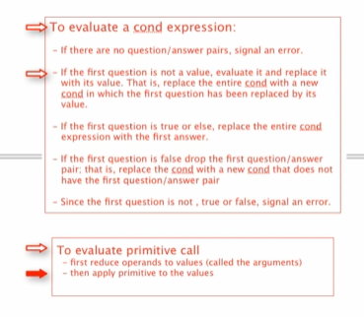 -> 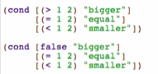

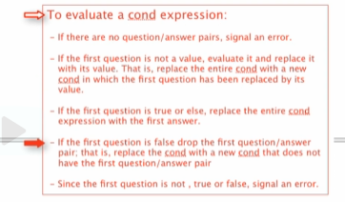 -> 

Evaluate again:

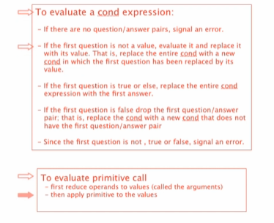 -> 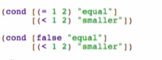

 -> 

And again:

  

  